Data Analysis Expressions (DAX) Contoso Sales File Assignment

1. Calculate Total SalesAmount on Contoso Sales file.
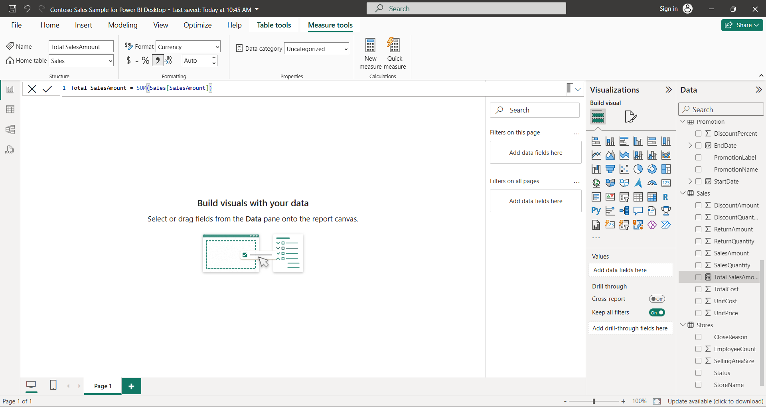

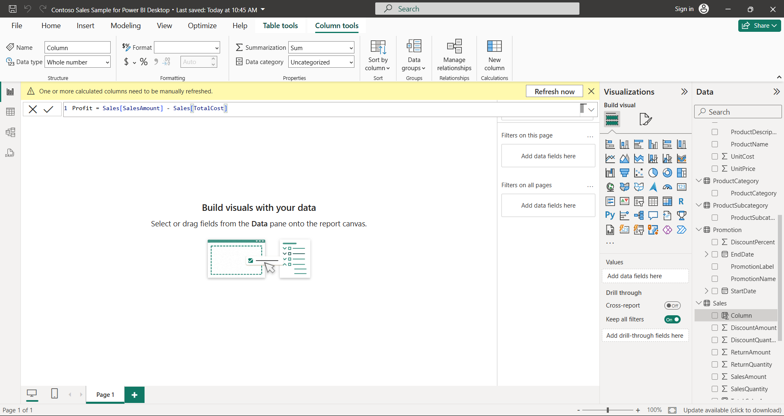
2. Create Profit column using arithmetic operator by subtracting SalesAmount and Totalcost.

3. Calculate total profit value for product key 800.
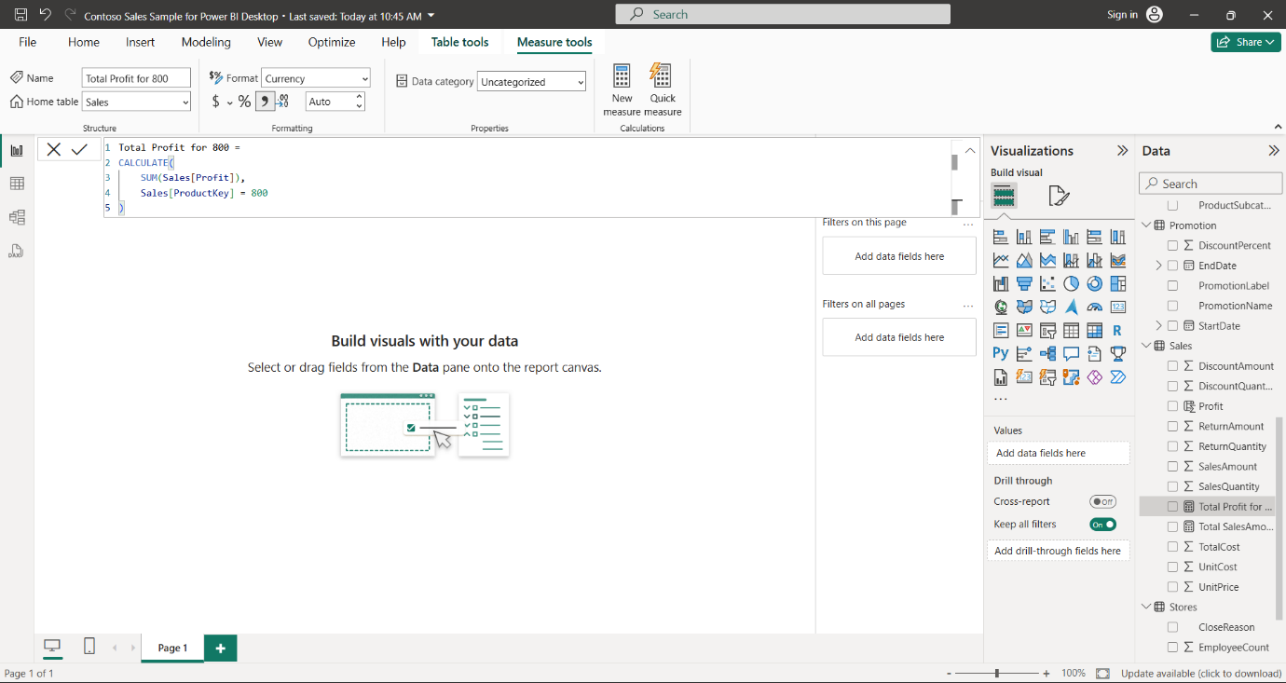

4. Replace Contoso Ltd manufacturer name by Contoso Pvt Ltd using DAX function.
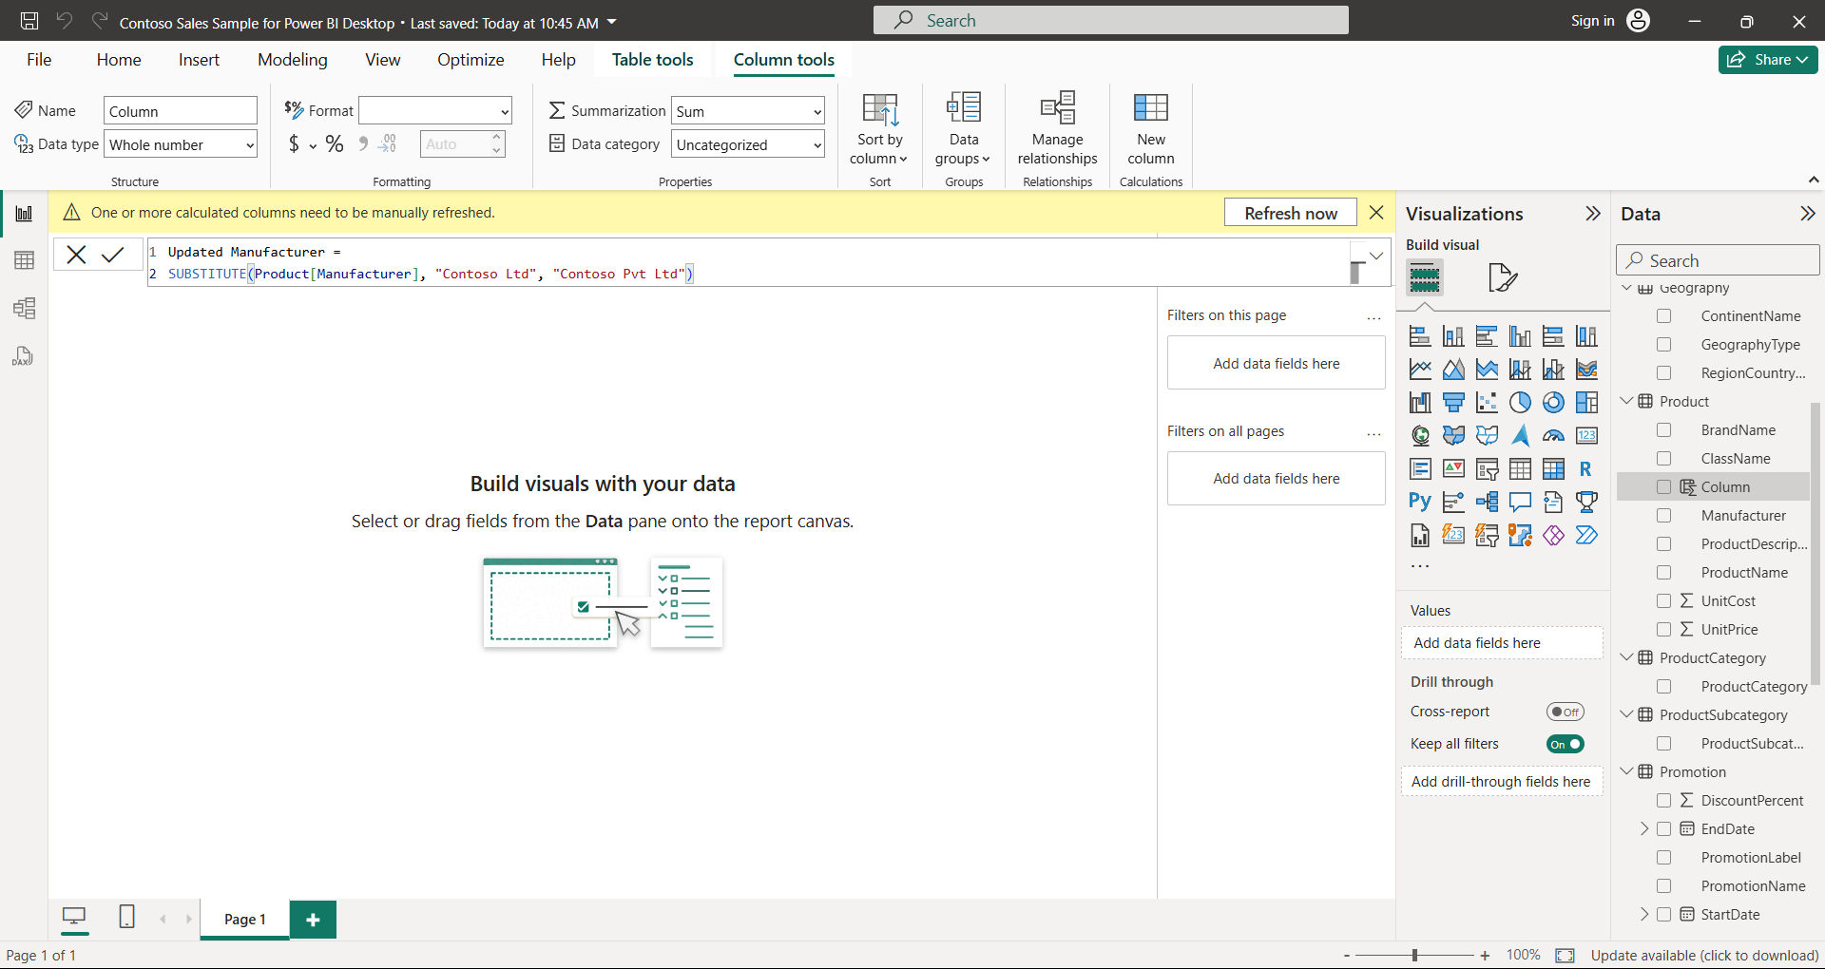

5. Create table with start date as mentioned in dataset and end date will be todays' date using DAX.
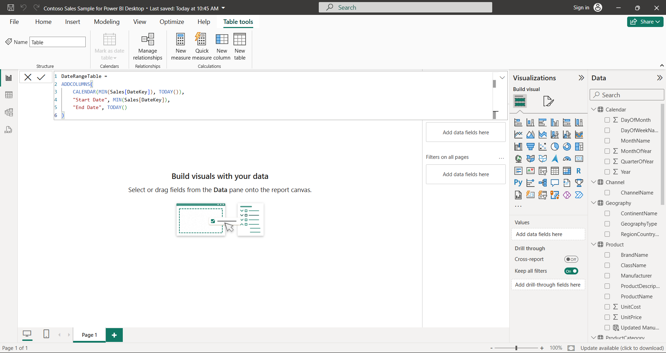

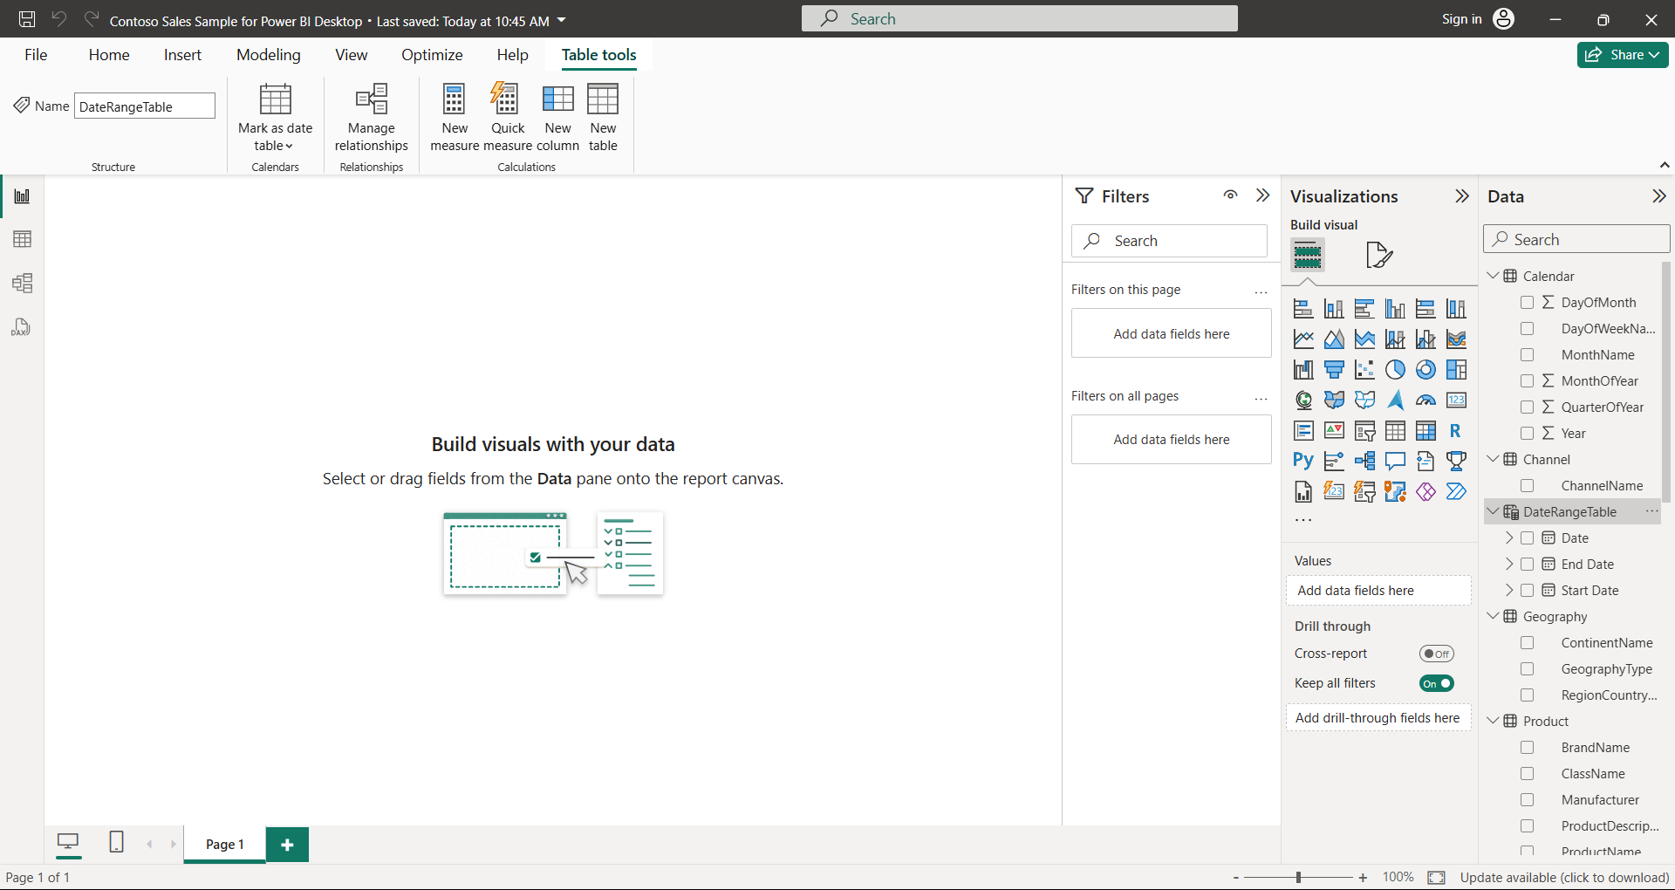

6. Perform division operation on SalesAmount and total cost for product key 800.
